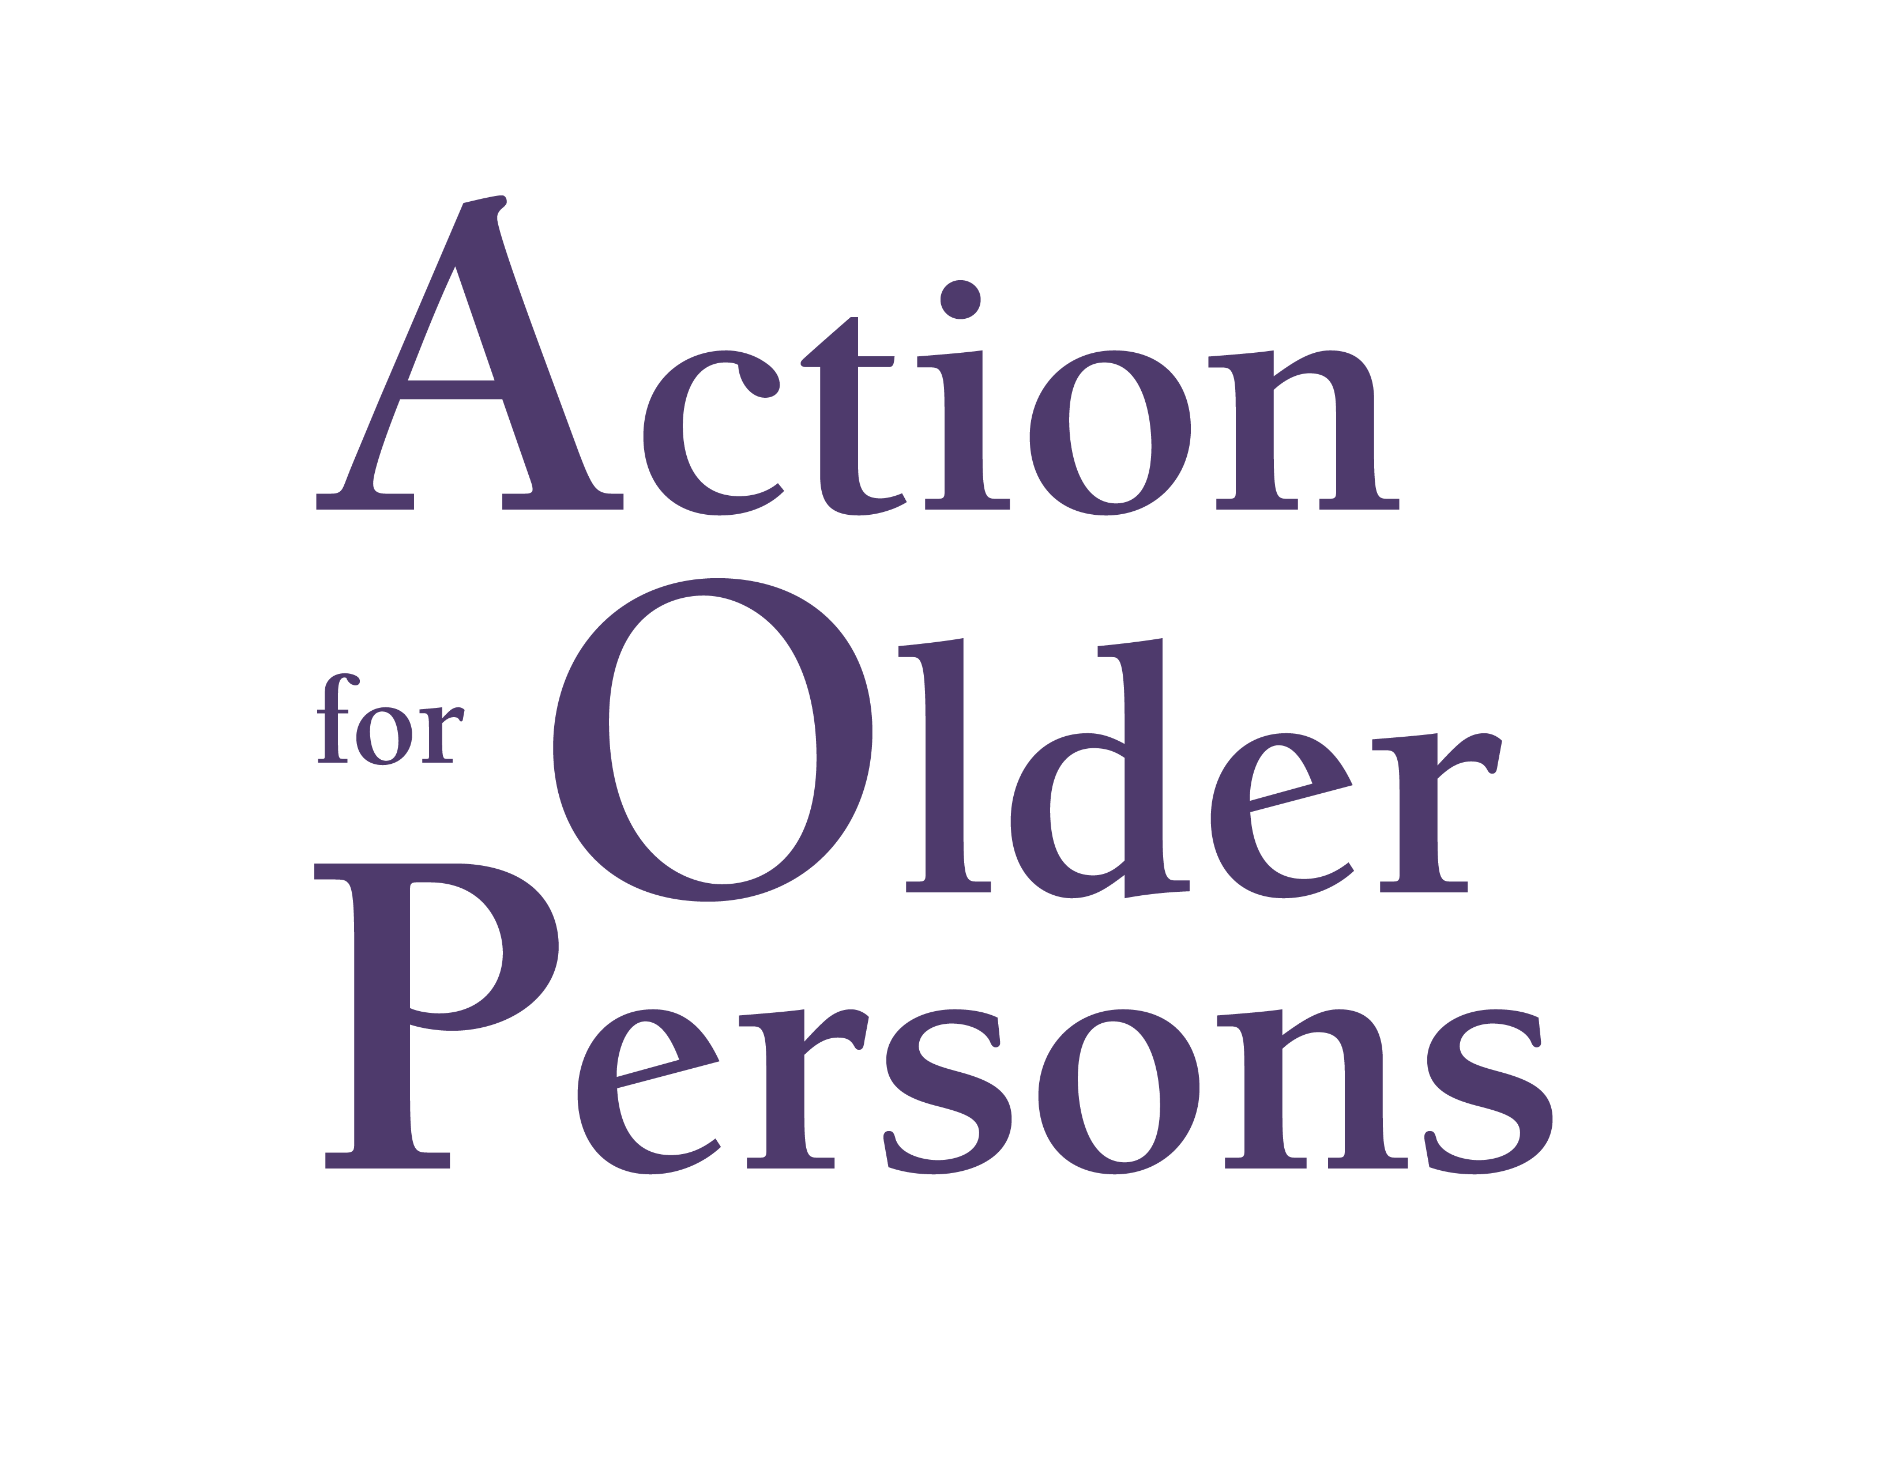
Information you can count on.
Assistance you can trust.

200 Plaza Drive Suite B Vestal, NY 13850
Phone: 607.722.1251 ◆ Fax: 607.722.1293 ◆ Website: www.ActionforOlderPersons.org

Program Coordinator
Health Insurance Information Counseling and Assistance Program (HIICAP)

HIICAP is New York State’s Senior Health Insurance Assistance Program. It receives federal funds from the Centers for Medicare and Medicaid Services to operate a statewide network of local programs that educate the public about Medicare, Medicaid, managed care, long-term care insurance, and other health insurance options and savings programs.

HIICAP assists individuals with Medicare (including those under 65) or persons soon to be eligible for Medicare with accessing needed health care and to apply for programs such as the Medicare Savings Programs (to pay the Medicare Part B premium.) Annually, AOP’s HIICAP staff and volunteers, provides one-on-one counseling assistance to 2,300-2,500 individuals and provides assistance to over 1,000 through educational seminars and outreach activites. The program rewarding, challenging, and fast paced.

Program Coordinator Responsibilities:

The Program Coordinator is the primary representative of the New York State HIICAP in Broome County, NY. The Program Coordinator is responsible for ensuring program compliance with the policies and procedures of the State HIICAP and other program funders.

HIICAP Expertise: Medicare is an extremely complicated program

Public Education/Public Speaking: The Program Coordinator provides public information, outreach and education regarding Medicare and issues affecting people with Medicare. This includes a four part series of monthly presentations at AOP’s offices and at other sites throughout the county an average of 40 times per year.

One-on-One Benefit Counseling: The Program Coordinator will also provide one-on-one assistance to Medicare Beneficiaries, particularly in the most challenging circumstances. This includes explanation of coverage options, plan enrollment and determination of eligibility for and enrollment in various needs based programs.

Data Tracking & Report Generation: The Program Coordinator maintains all paperwork and data entry obligations with the help of the Program Specialist and prepares/submits all reports in accordance with the Program’s contractual agreements.

Volunteer Management: The Program Coordinator supervises a team of volunteer senior health insurance counselors, and is responsible for:
  - recruiting, screening, training and supervising such volunteers;
  - assisting volunteers in conducting client counseling sessions and providing follow up with clients as appropriate; and
  - disseminating information and educational materials from the State HIICAP to volunteers.

The Program Coordinator is further responsible for ensuring:
- all volunteer training is conducted in accordance with State HIICAP requirements;
- client confidentiality is maintained in accordance with the agency’s Policy and Procedure on Confidentiality; and
- reports of actual or suspected Medicaid/Medicare fraud are reported to the appropriate law enforcement or State regulatory agencies.

Required Qualifications:
- Four years of progressively responsible experience in the field of human services, with at least one year of this experience having been in aging, long term care, or a closely related human services field. A bachelor’s degree in a health-related or human services field could be substituted for two years of general experience. A master’s degree could be substituted for one additional year of general experience. Part time experience and volunteer experience could be accepted on a pro-rated basis.
- Shall not have an interest or relationship which may interfere with, limit, or appear to interfere with or limit in any way the ability of the Program Coordinator to be objective, to fully inform clients of their health insurance options, to manage and direct the Program, or to comply with the policies and procedures of the State HIICAP.

Preferred Qualifications / Required Competencies:
Preferred Qualifications:
- Computer literacy
- Experience working with volunteers

Required Competencies:
- Ability to represent the agency in a professional manner with tact and diplomacy
- Strong oral and written communication skills
- Excellent interpersonal skills
- Ability to travel throughout geographic area covered by the Program

Position Benefits:
- Employer-sponsored health insurance plan
- retirement plan
- Vacation, holiday and personal time

